CLOUD FRONT

Lab 1 : crate s3 with all permissions
Step 1:
Create s3 bucket
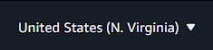
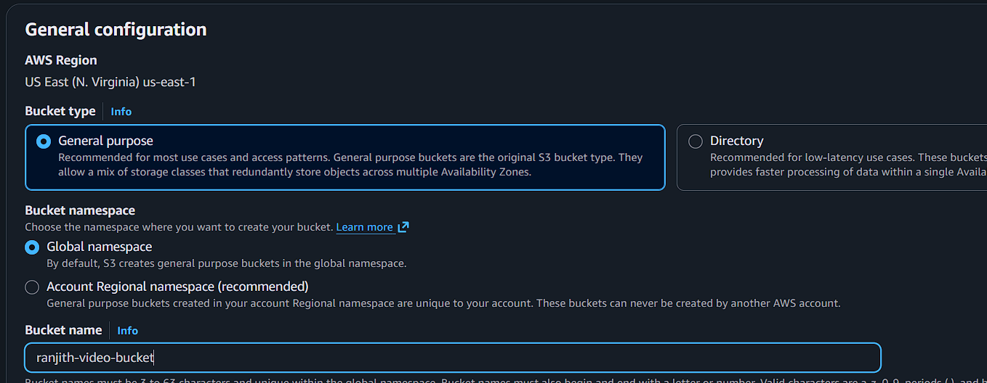
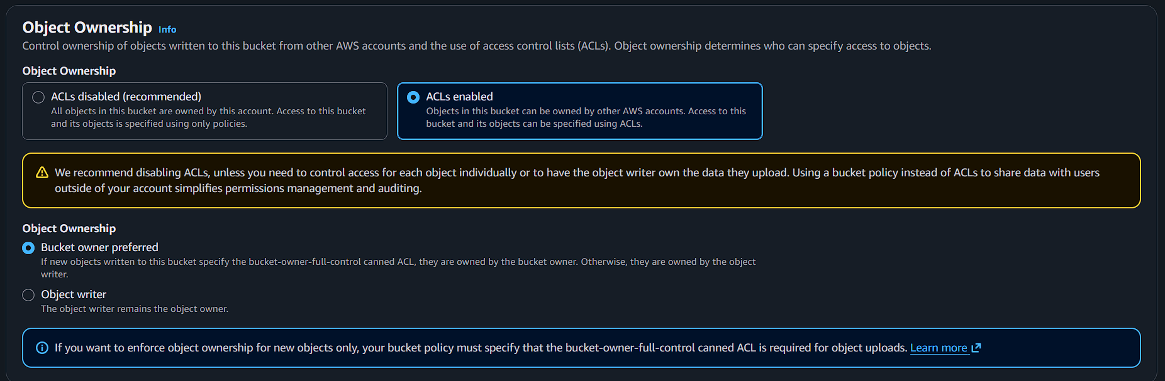
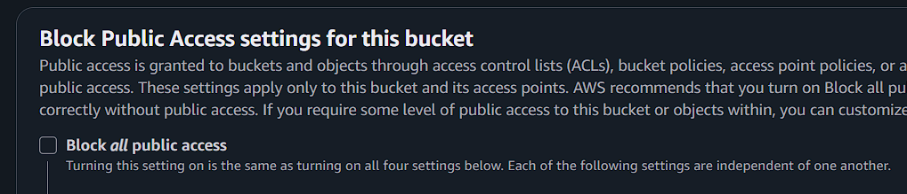

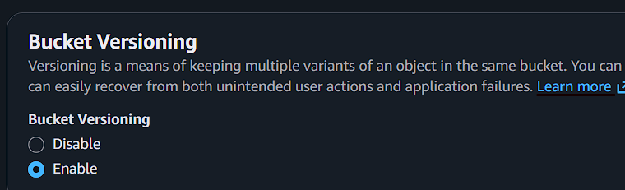
Go to bucket permissions
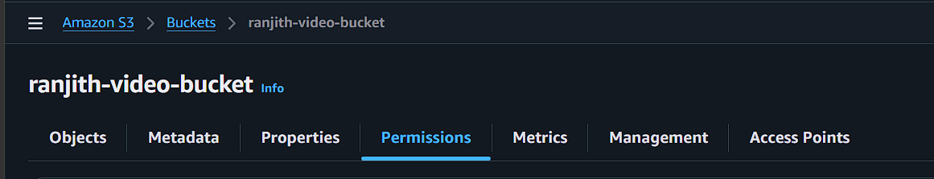
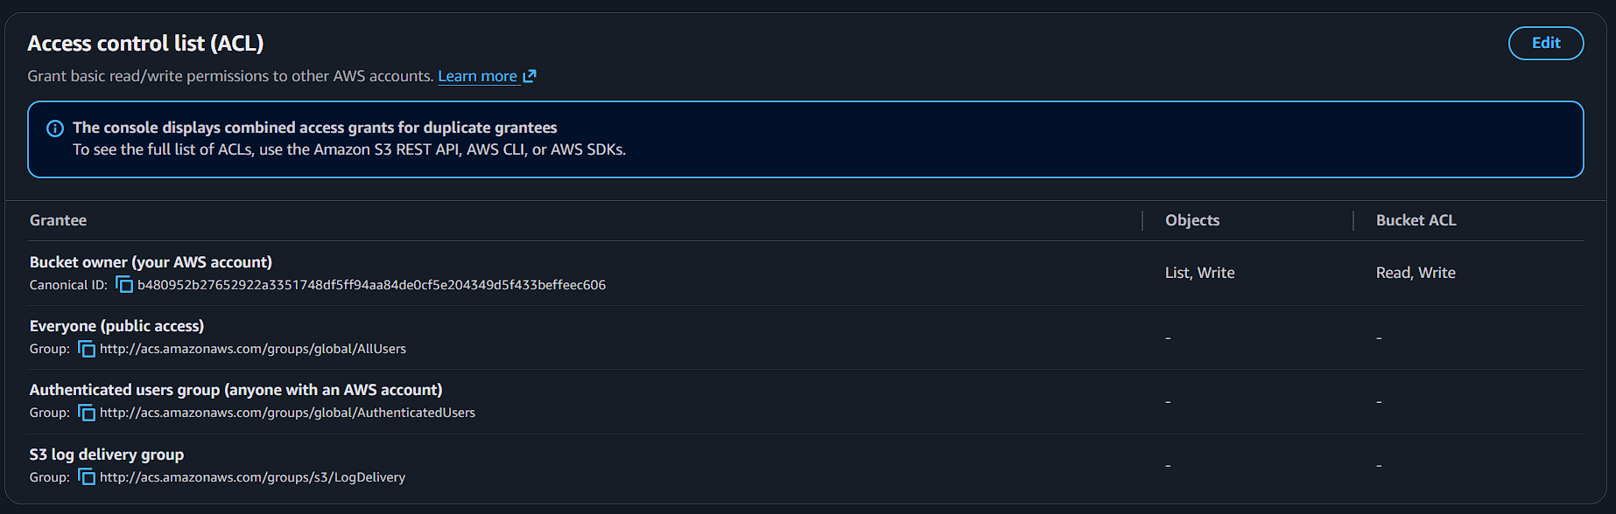
Enable all options
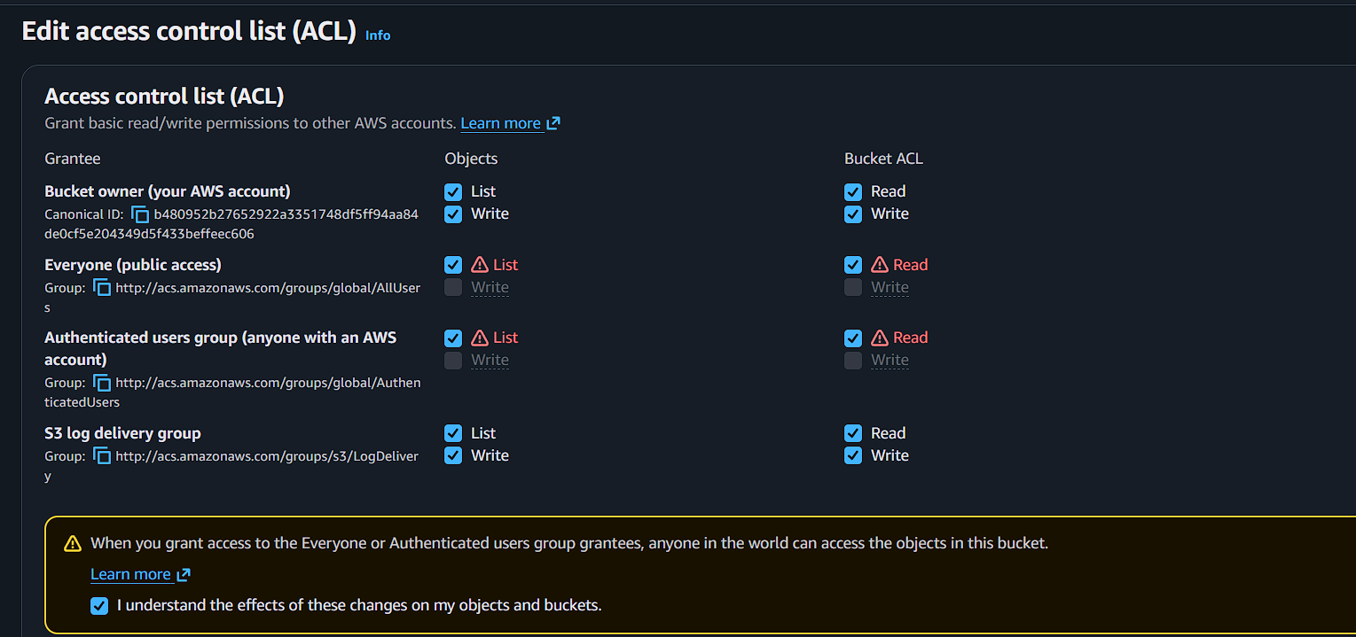

Upload any objects(video,photos,etc…)
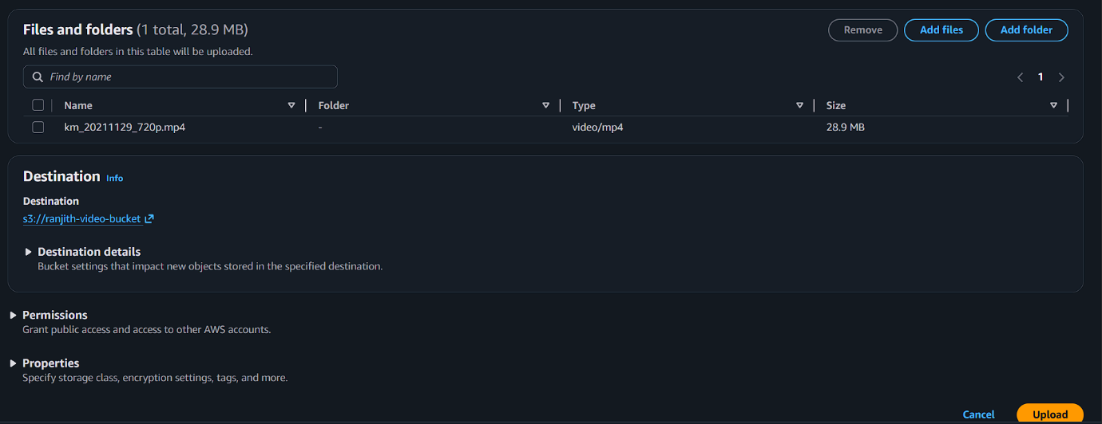
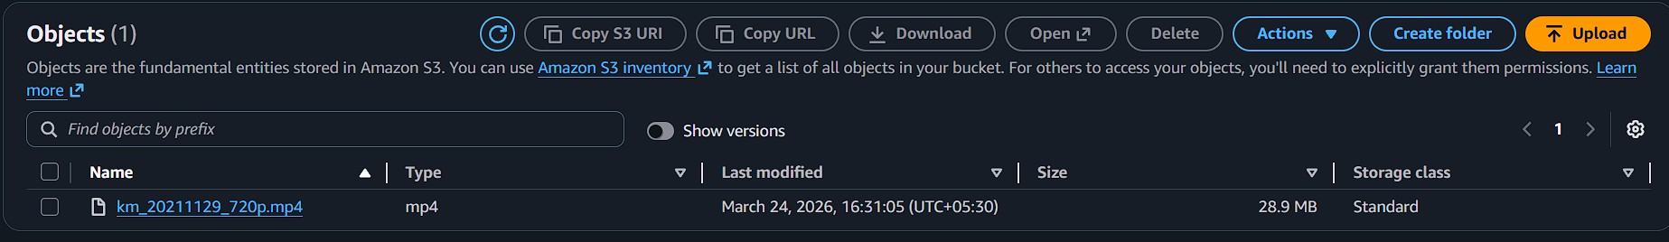
Give file permissions
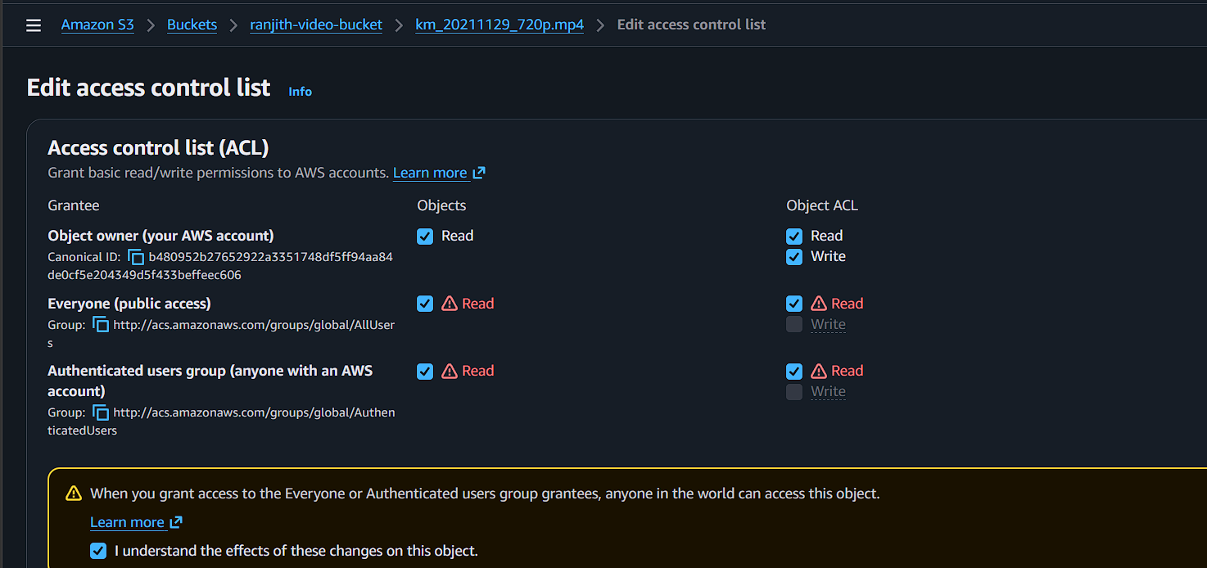
Now check in internet using file url
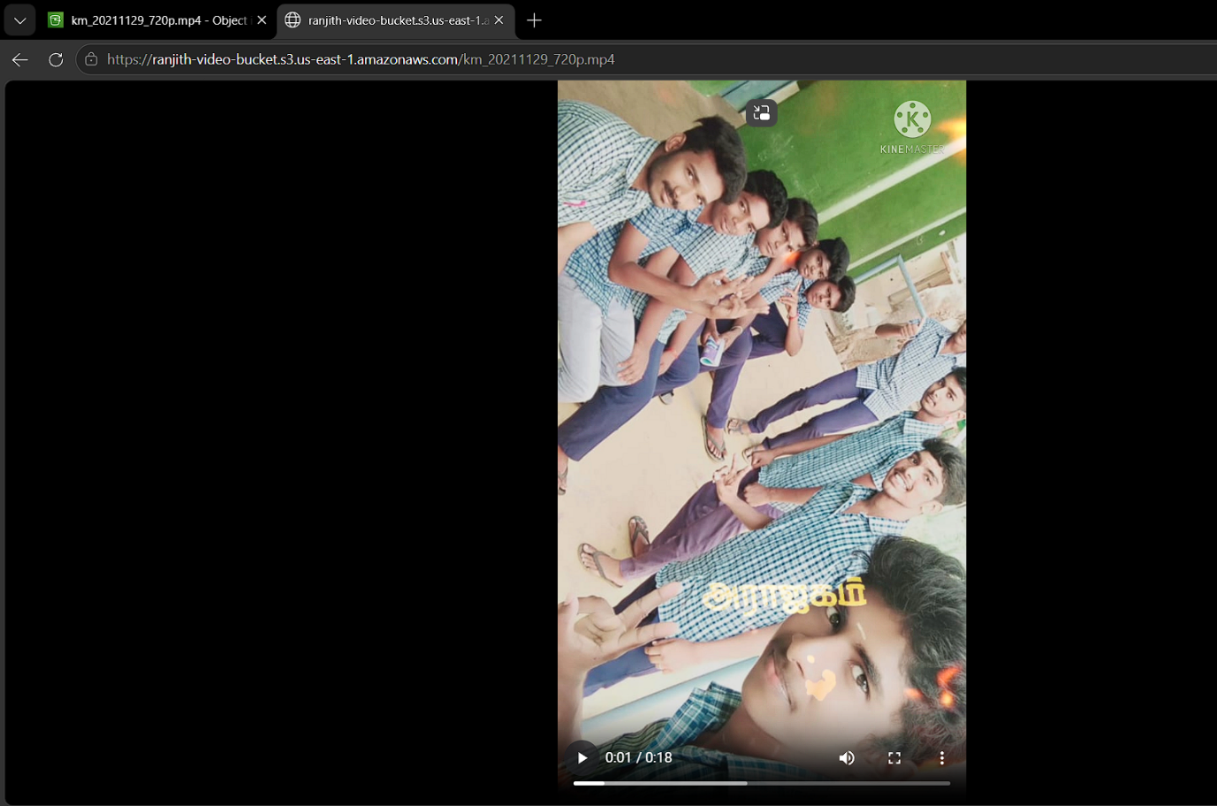
Its working

Lab 2:using cloud front without any s3 permissions

Create s3 bucket
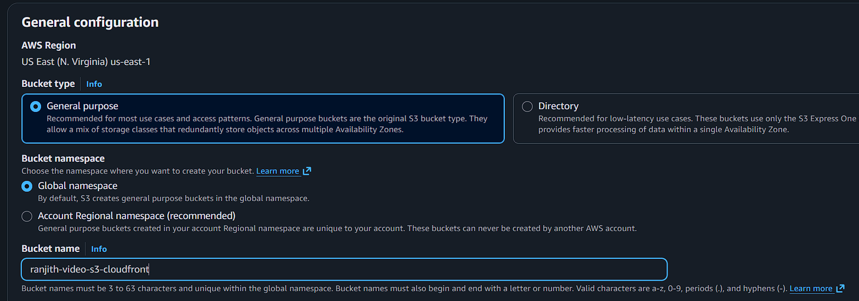

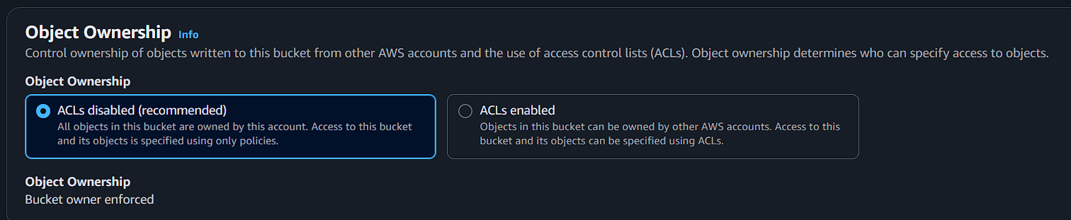

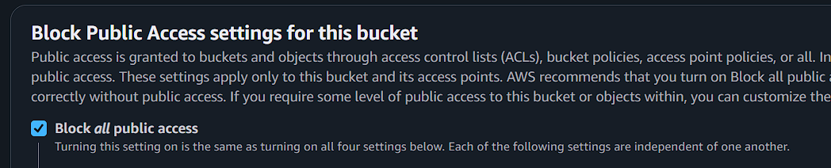

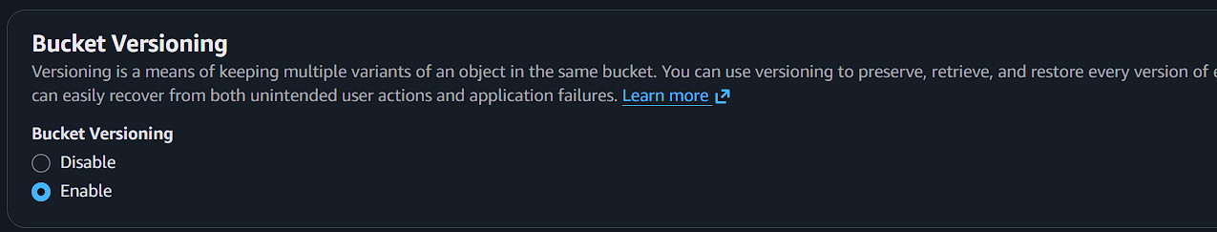
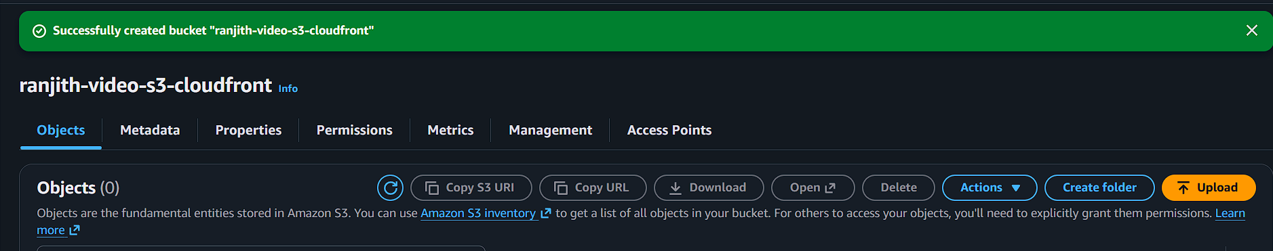
Now upload any video
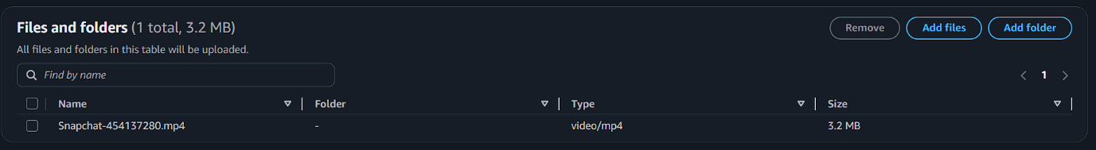

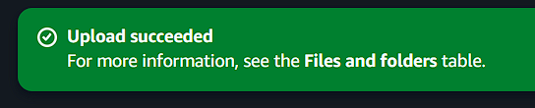
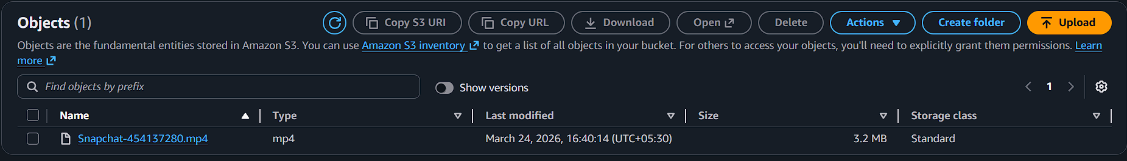
Now create cloudfront
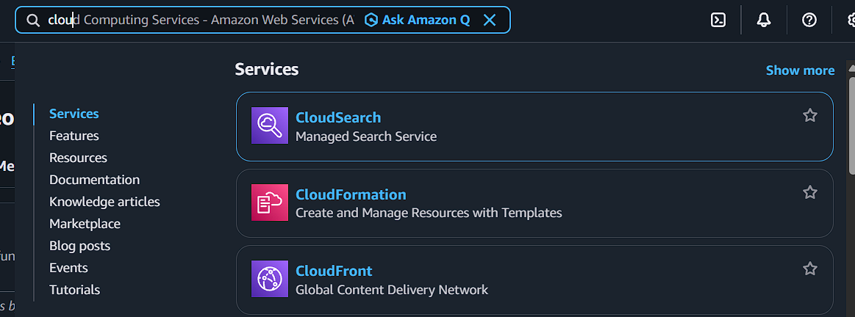
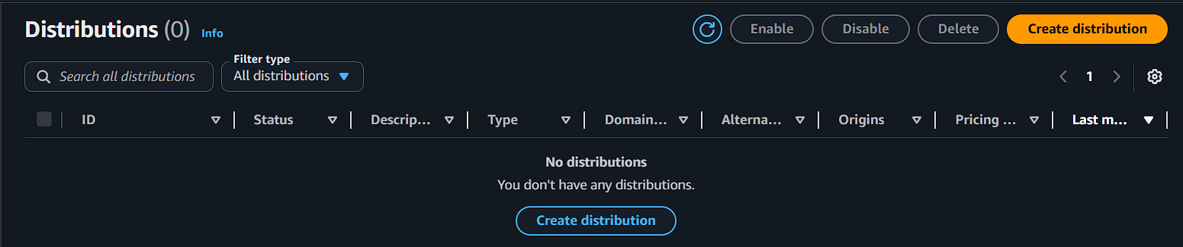
Click distribution

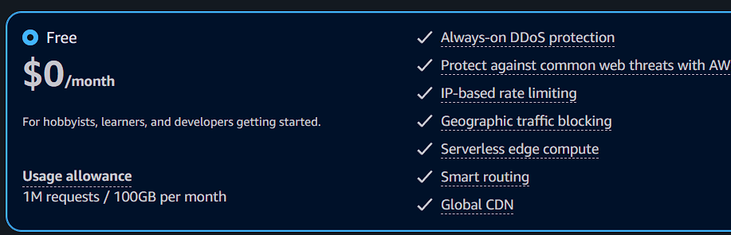

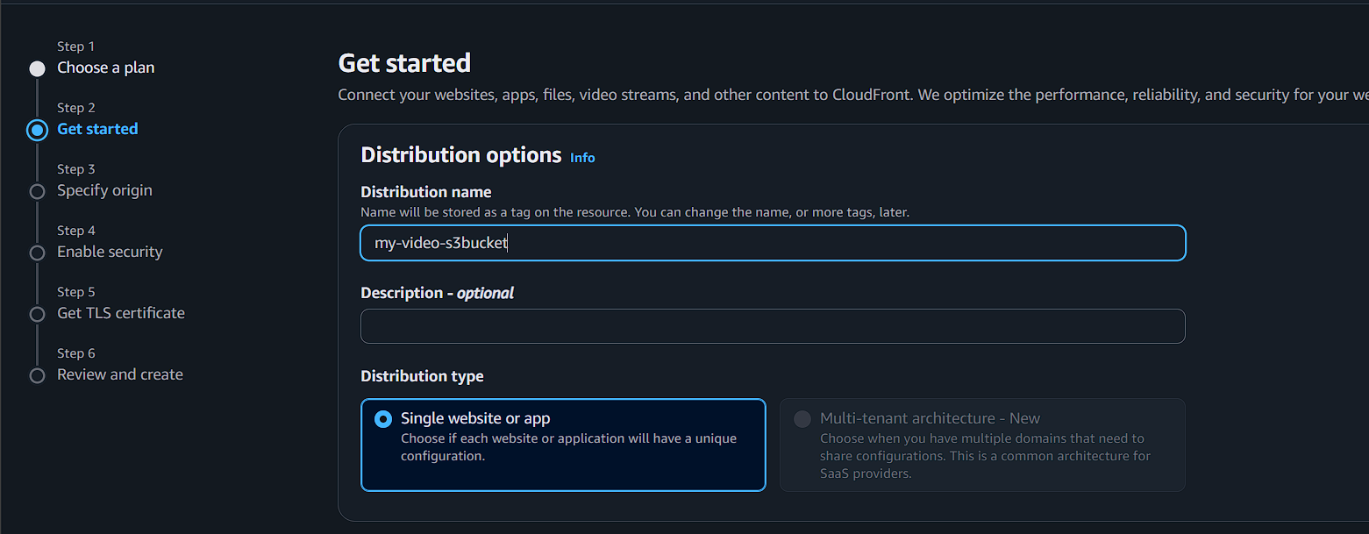
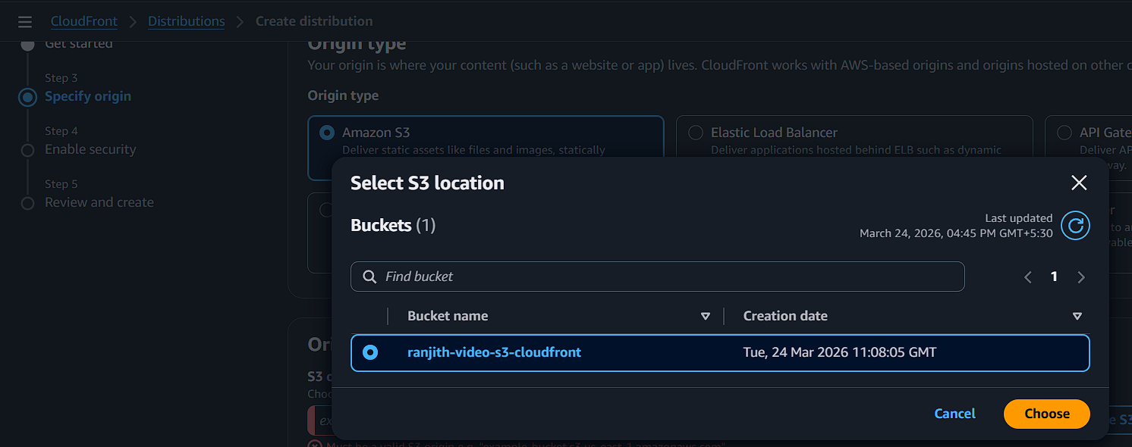

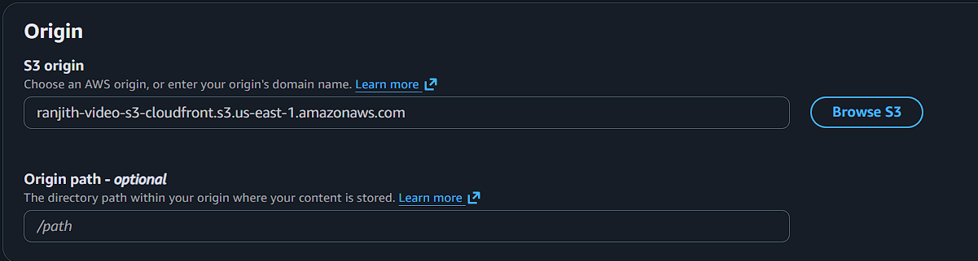

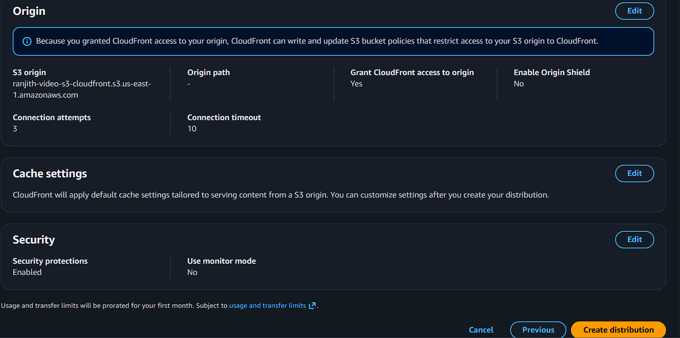
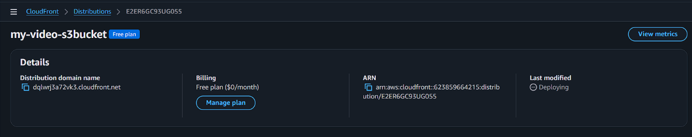
Deploying so wait few minutes

Copy the domainname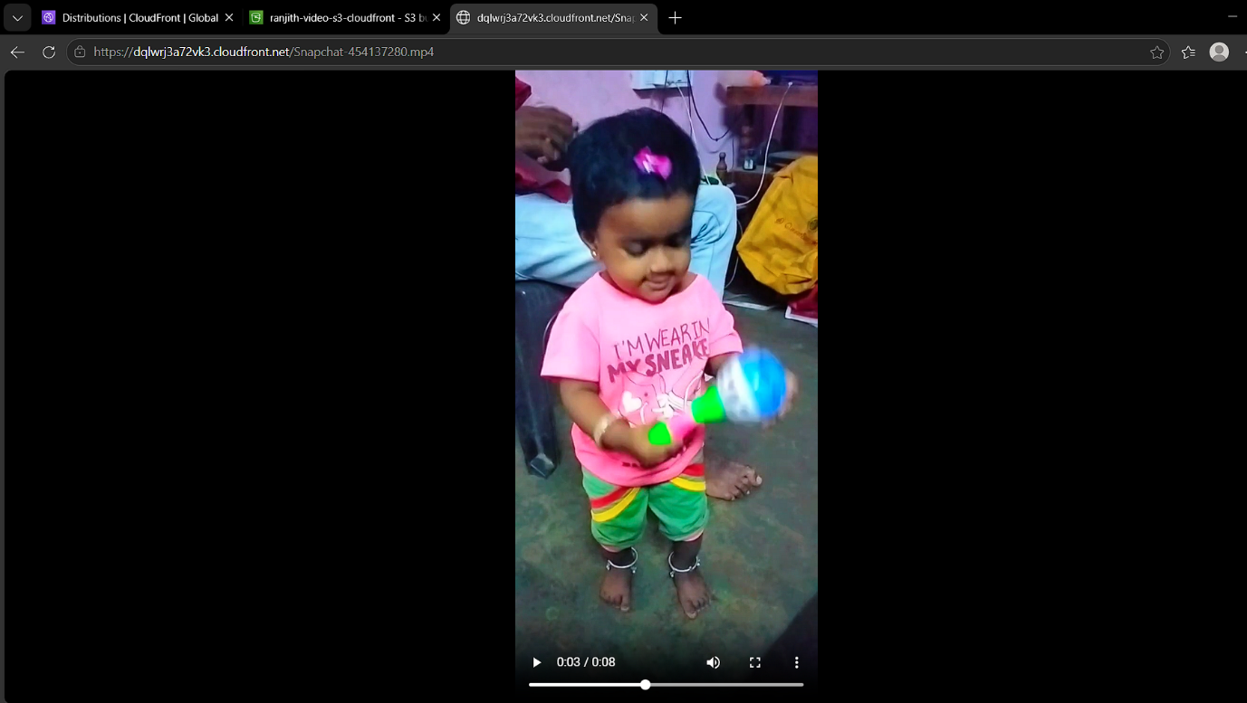
dqlwrj3a72vk3.cloudfront.net/Snapchat-454137280.mp4
(dqlwrj3a72vk3.cloudfront.net)-domain name for cloundfront
(/Snapchat-454137280.mp4) -implemented video file name

